# PARTICIPATION AGREEMENT

I understand that Health Promotion ("HP") at Appalachian State University ("ASU" or the "University") may refer me to an Athletic Trainer in the Department of Health and Exercise Science ("HES") for purposes of treatment and rehabilitation from athletic injuries sustained while participating in one or more HP-sponsored activities, and that the treatment and rehabilitation services will be provided to me at no charge. I further understand that the Athletic Trainer is supervised by a physician and will work under an athletic training protocol signed by that physician. I also understand that any regimen of treatment may involve risks, including but not limited to, the exacerbation of injuries. Despite such potential risks, I wish to have the treatment and rehabilitation services provided to me by the HES Athletic Trainer, and I assume sole and full responsibility for my safety with respect to the provision of these services.

In consideration of being provided treatment and rehabilitation services by the HES Athletic Trainer, I agree as follows:

1. I will comply with all instructions and directions of Appalachian State University officials, staff, and volunteers before, during, or after the provision of treatment and rehabilitation services.
2. I understand the possible risks and dangers to me and my life and property associated with the provision of treatment and rehabilitation services, and I participate voluntarily in reliance upon my judgment and ability. I assume all risks of personal injury, death, and property damage or loss from any cause whatsoever, including, but not limited to, my own conduct, the failure of anyone to enforce rules and regulations or inspect equipment or facilities, and the negligence of anyone else; and
3. I release and shall indemnify, defend and safe harmless Appalachian State University, The University of North Carolina, the State of North Carolina and their respective trustee, agents, volunteers, and employees from all liabilities, losses, costs, damages, claims or causes of action of any kind or nature whatsoever, and expenses, including attorneys' fees, arising or claimed to a have arisen out of personal injuries or death, or property damage or loss, sustained by me as a result of any causes whatsoever, including, but not limited to, my own conduct, negligence or other misconduct on the part of Appalachian State University trustees, agents, volunteers, or employees, or those injuries or property damage sustained by others as a result of my own negligence or intentional acts, during my participation in these Activities (including any travel to and from the Activities' sites). North Carolina law governs the determination of all issues related to this Agreement.

I certify that I am at least eighteen (18) years of age, medically and mentally sound, physically fit to receive the treatment and rehabilitation services described above, and competent to enter into this waiver and release agreement. I further certify that no oral promise, agreement, warranty or representation concerning safety or liability or other legal issues has been made to me, and that I have been encouraged to consult with my own attorney prior to signing this document. **If the participant is under eighteen (18} years of age, this document must be signed on behalf of the participant by his or her parent or guardian.**

# I HAVE READ AND UNDERSTAND THIS ASSUMPTION OF RISK AND INDEMNIFICATION AGREEMENT. I UNDERSTAND AND AGREE THAT IT WILL LEGALLY BIND ME AND MY ESTATE, AND I SIGN IT VOLUNTARILY.

Signature Date

Patient's Name: Department/Office: Phone: _

**Date: _**

**Email: _**

Referring HP Staff Member: _

Chief Complaint:

Did this injury occur while participating in an HP sponsored activity? **YES NO**

Is this injury work related? YES NO Carolyn Bosley@ 262-6488.

**If yes, stop here and contact Worker's Compensation Administrator**

Please explain how your injury occurred:

**Have you had a previous injury to this body area?** YES NO

**If yes, explain:** _

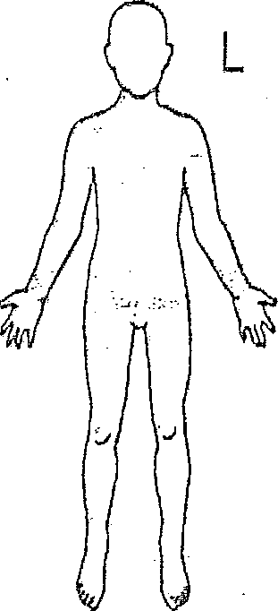A black and white drawing of the back of a person's body
Indicate area of Injury / Pain

Have you seen a physician for this condition? YES NO

If yes, please give contact information:

May I contact your physician to discuss your injury? YES NO

Please list any medical conditions (these may affect methods of treatment):

Please list current medications:

Would you allow an athletic training student to help care for your injury under the supervision of a certified athletic

**TRAINER?** YES NO

Contact Laurie Rivera, Med, LAT, ATC at 262-7431 or [riverala@appstate.edu,](mailto:riverala@appstate.edu) for an appointment. Athletic Trainers are health care practitioners specializing in the prevention, recognition, treatment and rehabilitation of athletic injuries. **A physician referral may be required for treatment.**